Name: Worksheet -Revision
Grade: II
Subject: English
I. Write the plural form of the naming word.
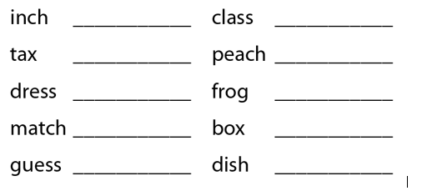
II.Write a sentence of your own using the singular or plural form of each word.
- book __________

- mango _________
_________________________________________________________
- class _________
_________________________________________________________

III. Fill in the blanks with ‘a’ or ‘an’.
- My brother has __________ big toy.
- ________ apple a day keeps _______ doctor away.
- There is _________ umbrella in my bag.
- He is ________ Indian.
- Jim reads ___________ story every day.
IV. Identify three things around you and write three sentences using an article ‘a’ or ‘an’.
1.__________________________________________________________
2. _________________________________________________________
3. _________________________________________________________

